WORKSHEETUNIT 1: “Welcome”

Name:
Class: ______ | Date:
OBJETIVO GENERAL: Identificar vocabulario de la unidad y aplicarlo en estructuras gramaticales simples.

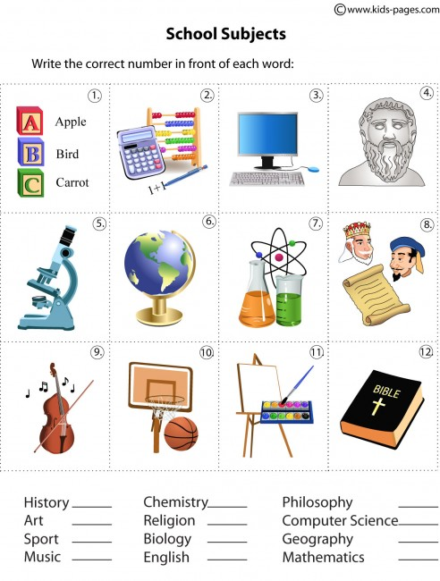  1. | 2.
3.

Answer the following question:
What’s your favourite subject?…………………………………………
………………………………………………………………………………………………… .

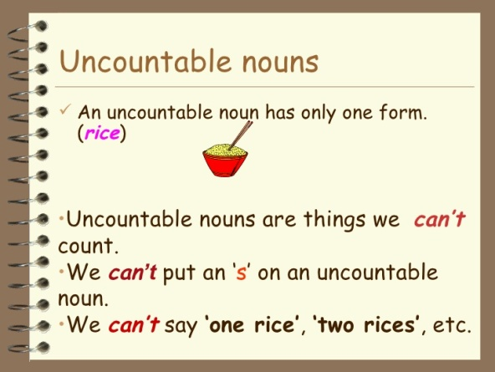  ……………………… ……………………  ……………………… ……………………  ……………………… ……………………  ……………………… ……………………  ……………………… ……………………  ……………………… ……………………  ……………………… ……………………  ……………………… ……………………  ……………………… ……………………  ……………………… ……………………  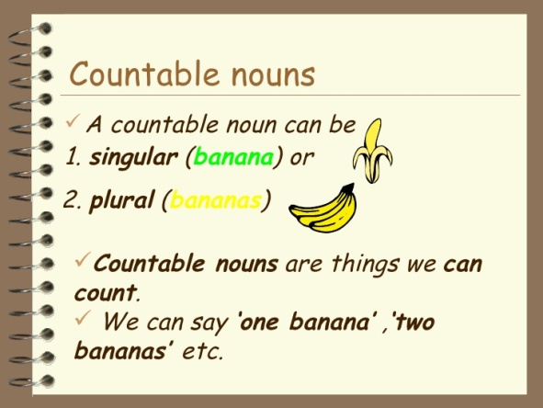 | 1.Classify the nouns between COUNTABLES or UNCOUNTABLES.

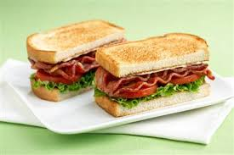

……………………………………………………..

Complete with SOME or ANY

- We use ……………. in questions

Ex.:…………………………………………………

- We use ……………. in negative sentences.
Ex.:………………………………………………

- We use ……………. in positive sentences.

Ex.:……………………………………………….

